# 

Source Control for test automation with GIt

# Table of Contents

A. Purpose 3

B. Prerequisites: 3

C. Steps 3

D. Create pull requests from TFS 6

E. Tips & tricks: 9

# **Purpose**

The purpose of this document is to know how to clone, pull, push the automation code

& Also, to facilitate the integrating of the automation work between the team members

# **Prerequisites:**

1. Make sure that your visual studio version is 16.8.0 or higher
   * In case you have lower version, you will have to update it
   * Press on window then type "visual studio installer" & then select the update option
2. Make sure you have .Net Framework 5
   * In case you have lower version
   * Go to : <https://dotnet.microsoft.com/en-us/download/dotnet/5.0>
   * Select the latest version: i.e., 5.0.16
   * Then download the Windows version i.e., x64

# **Steps**

1. **Clone your project**
   * 1. Open TFS: <https://projects.integrant.com/TFS/Neurocrine/NLIMS>
     2. From Repos>> Click on files then press on clone

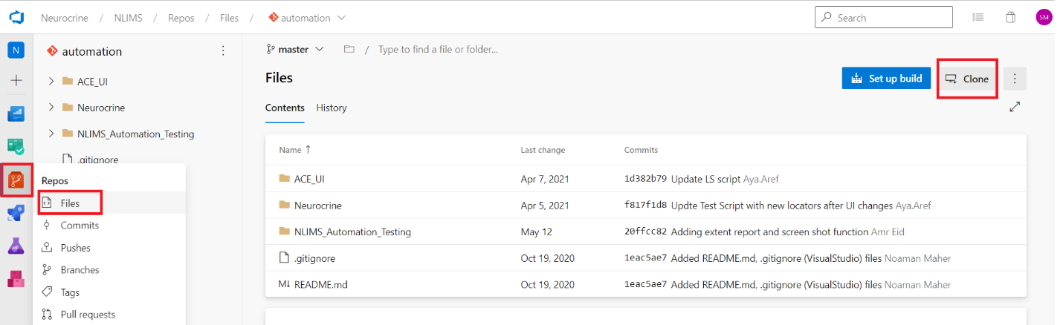

* + 1. Copy the link

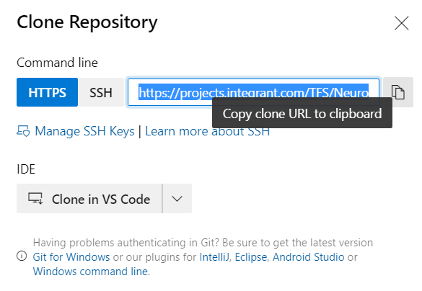

* + 1. Open Microsoft visual studio & select to “clone a repository”

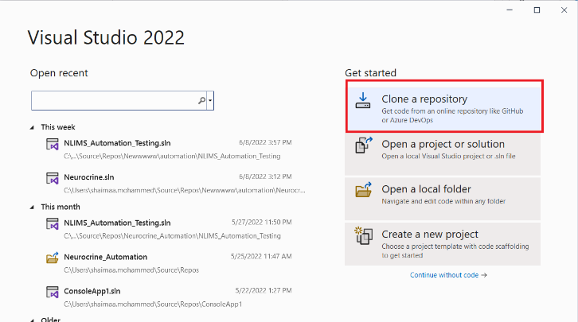

1. Past the URL you just copied in step 4 & past it
   1. Take care about the local path that will be saved in

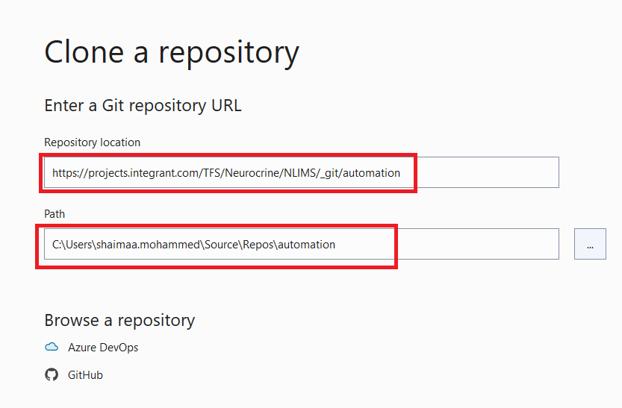

7. Now you have the project on your local machine 😊

1. **Make “Pull” before creating any new branch to get the latest changes done on the master**

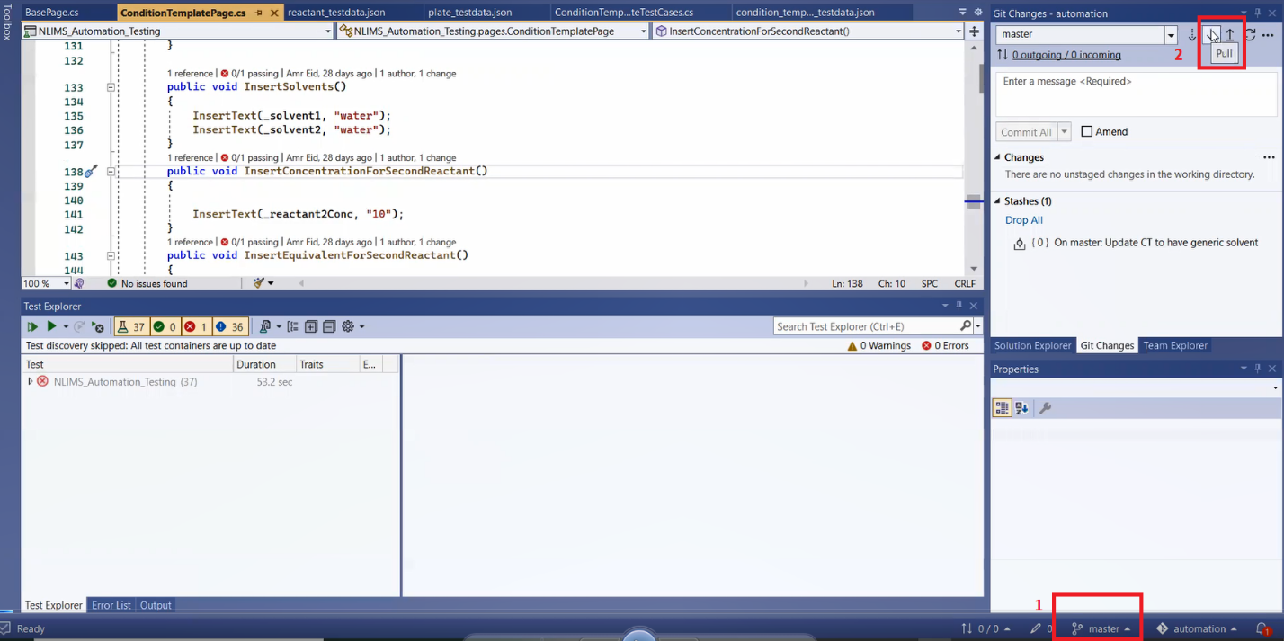

1. **Create new branch per feature**

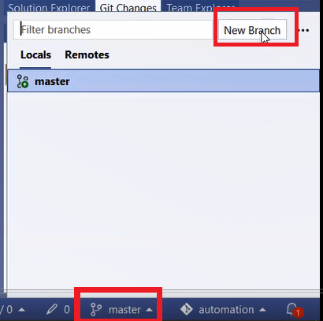

* You must create new the new branch on the master
* Branch name must have the following naming convention:

“tfs-TaskNumberOnTFS-featureName”

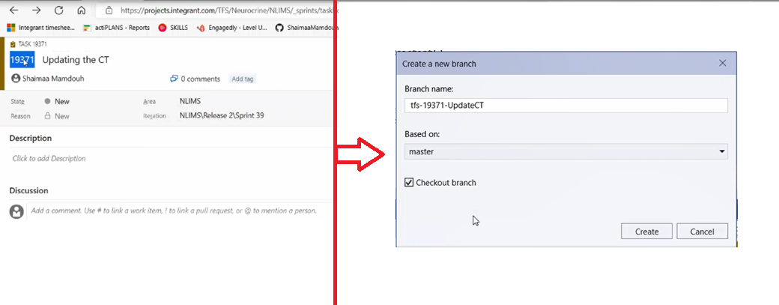

1. **You can commit your work**

* If you commit your work, it still saved on your local machine only

1. **It’s time to Push your changes**

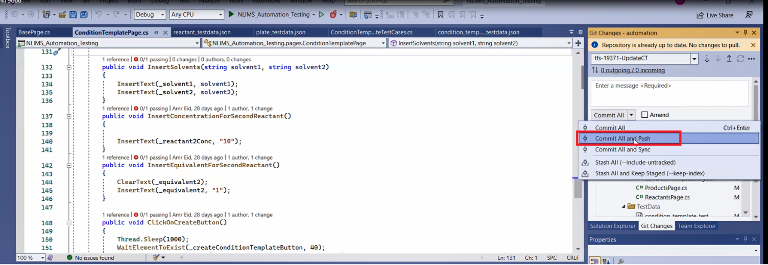

**Hint:** you can pick some files to be staged then pushed 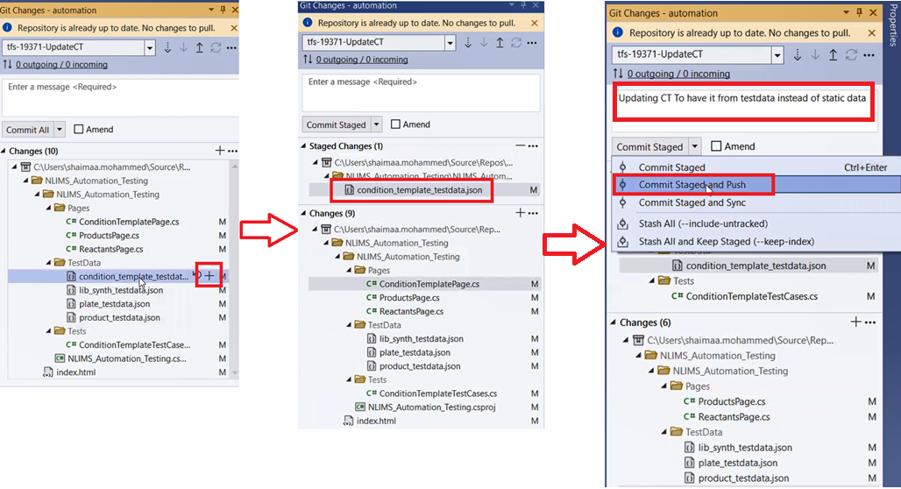

# **Create pull requests from TFS**

1. From Repo >> Click on pull requests

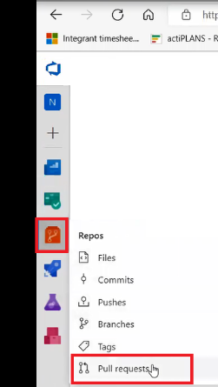

1. Click on Create a pull request

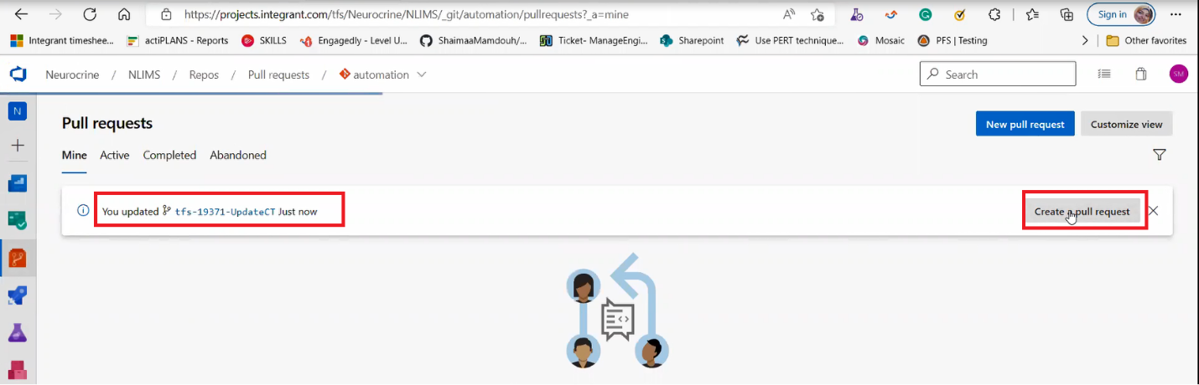

1. Fill the mandatory fields & don’t forget to link your work item

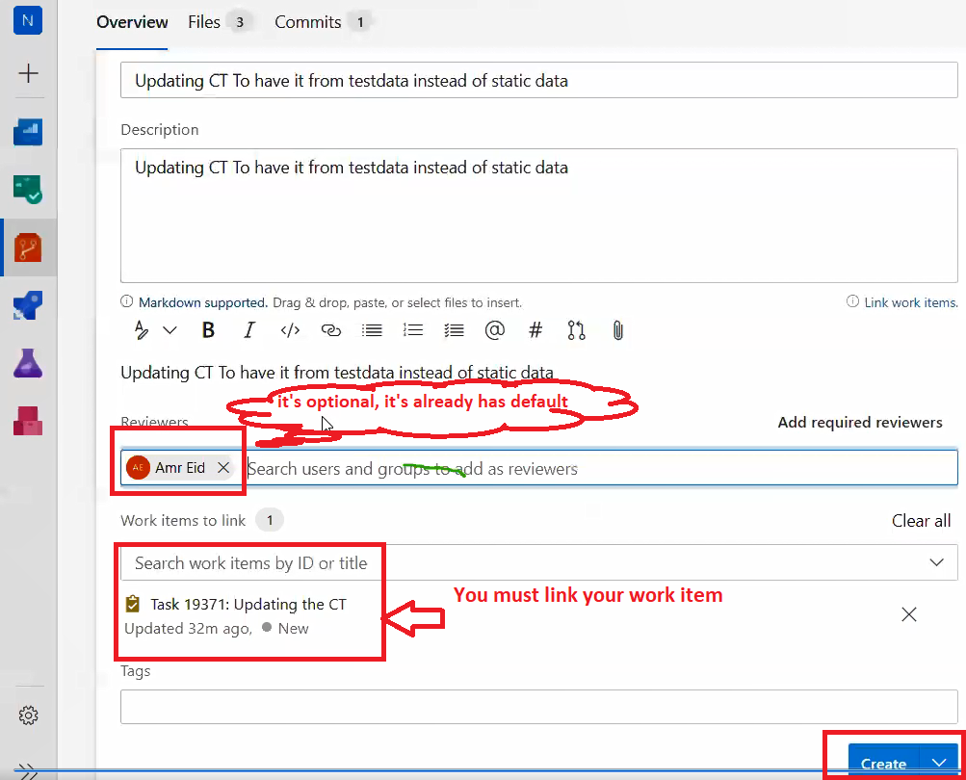

1. Then the reviewer can review the changes

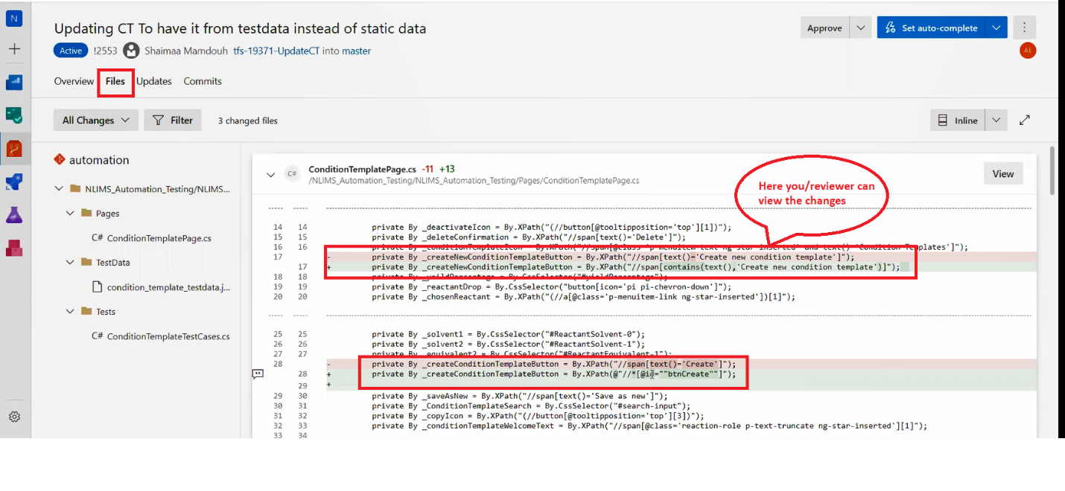

1. If the reviewer has some comments on this pull request, he will add the comments & change the status to be: “Wait for author”

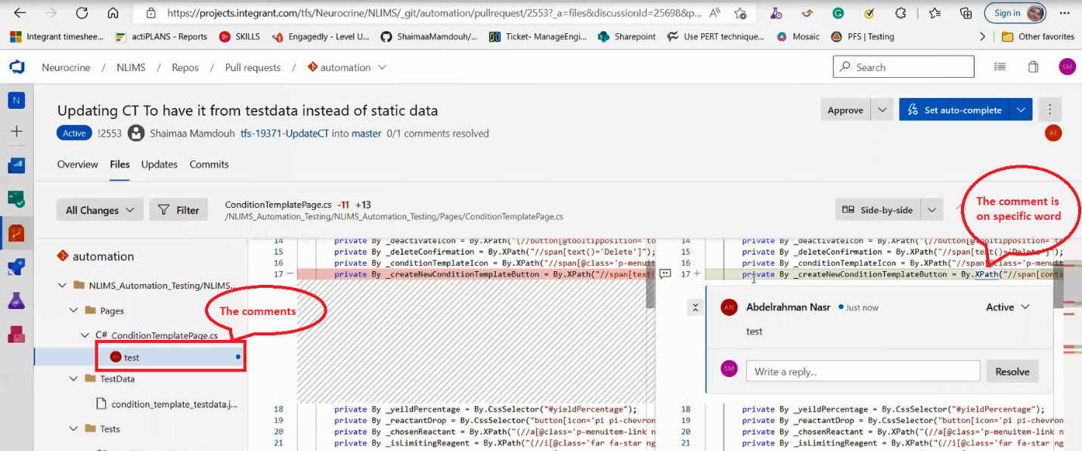

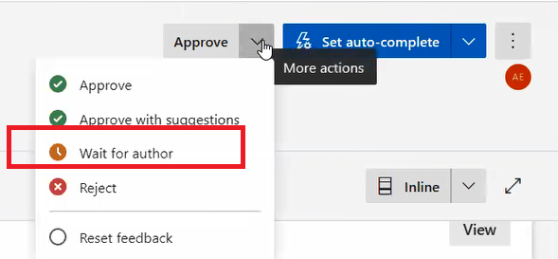

1. The you have to update your code based on the reviewer comments & **push the changes**, Then change the comment status to be “Pending”
   1. Hint: The new changes will be on the same pull request

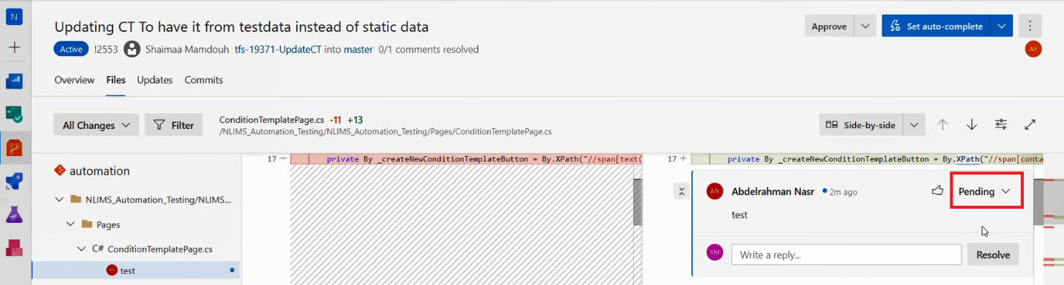

# **Tips & tricks:**

1. Every feature should have its branch
2. You **can’t** pull & update then push to the master directly (No permission allowed for this)
3. If you made changes on the master branch & forget to create your own branch you can follow the below steps:
   1. You can stash your work (Keep it on the local machine till creating new branch)

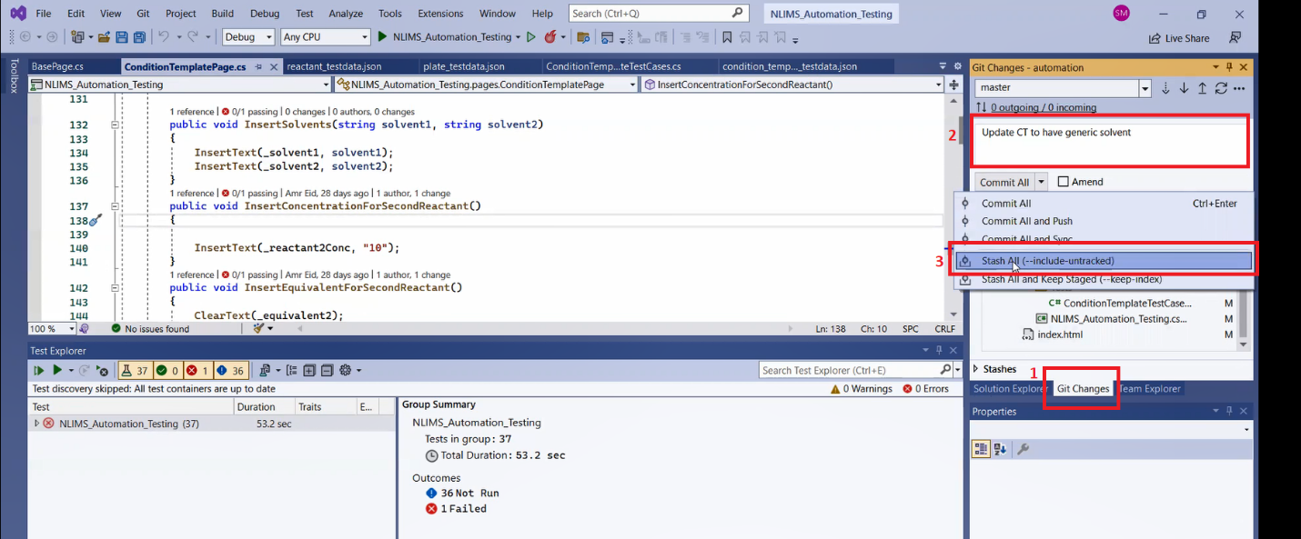

* 1. Create the new branch
  2. Move the stashed work to the created branch

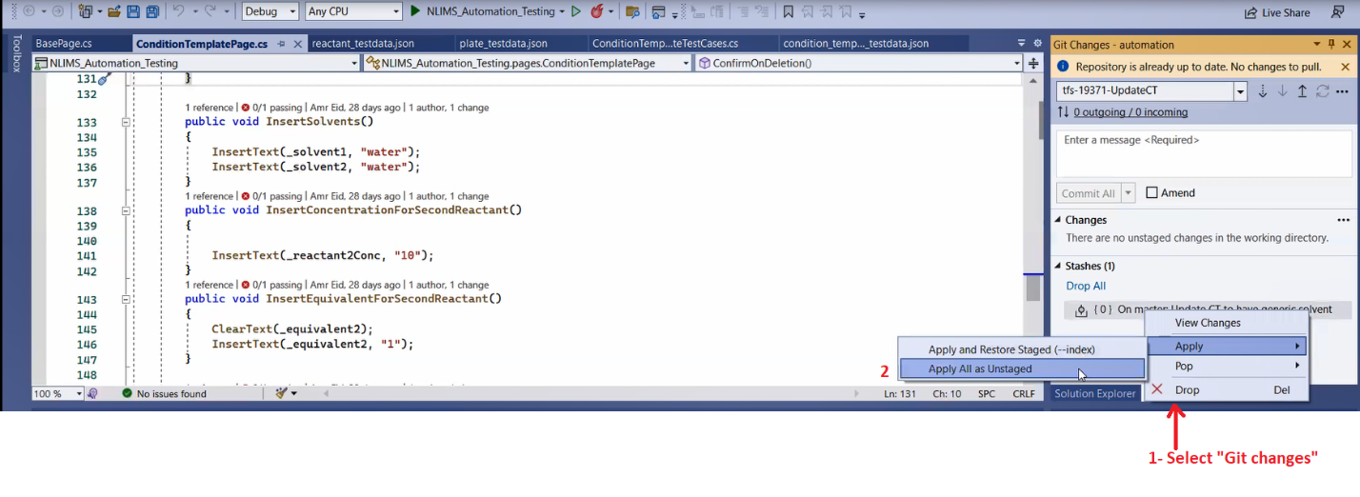

1. To view the changes, you made
   1. Click on “Git changes” & all the changed files will be displayed to you
   2. By double clicking on it the changes will be displayed in the right

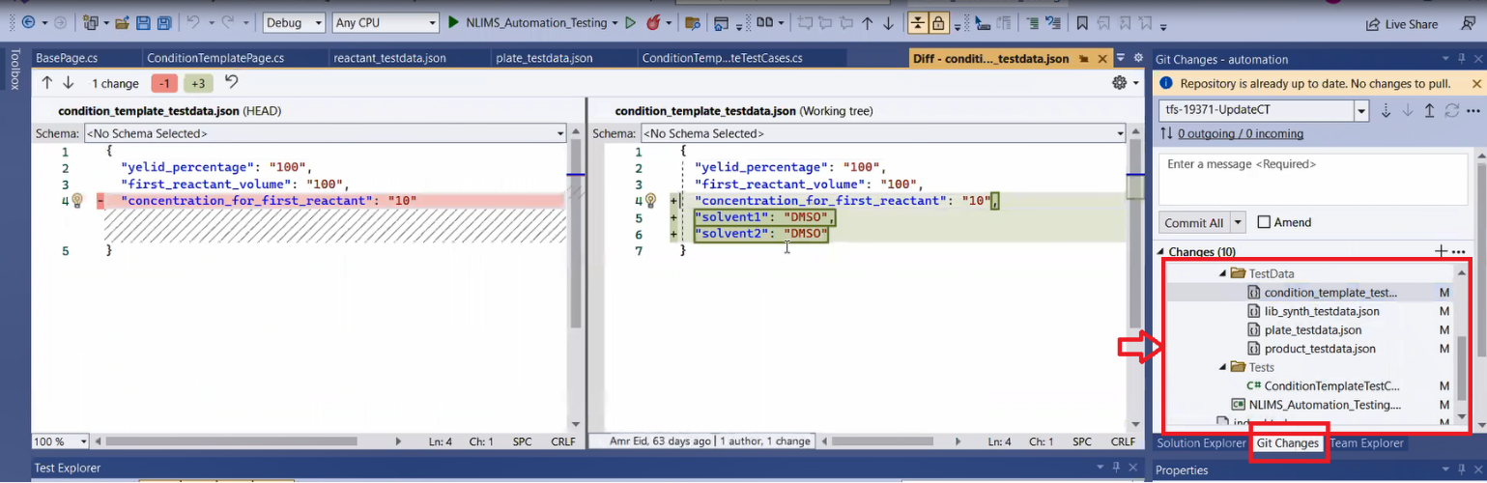

1. Anyone can make comments on you pull request(s) & it must only be approved by the default/selected reviewer.
2. If you create branch by mistake not on the master, you can delete it by follow the below steps:
   1. Navigate to the solution path
      1. From solution explorer, select “Open folder …”

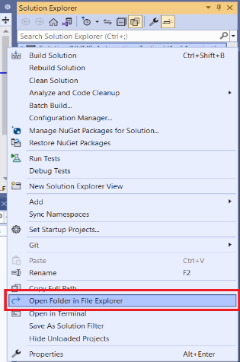

* + 1. Copy the address

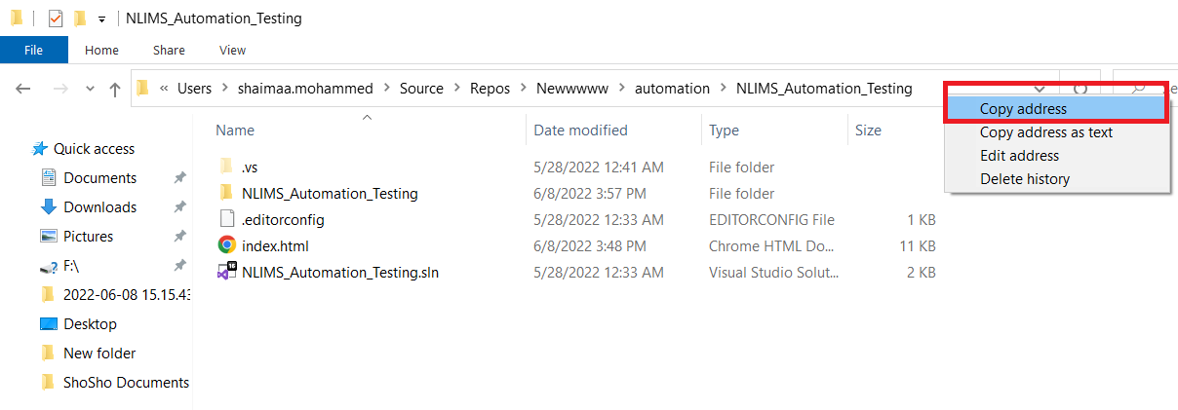

* + 1. Open Git Bash and navigate to the copied address

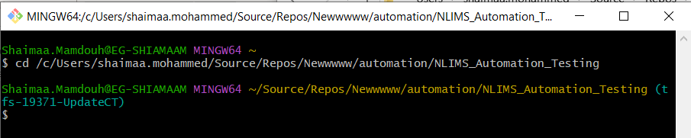

* + 1. Navigate to master branch

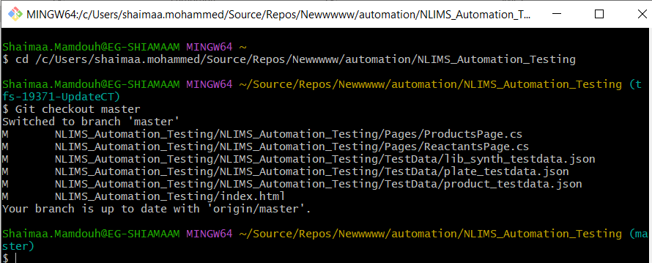

* + 1. Now delete the wrong created branch (Git branch -d “branchName”)

